AGNEL INSTITUTE OF TECHNOLOGY & DESIGN

**EXP NO :- 2**

**Commands :**

1]

sh anyfile.sh

hello world



sh anyfile.sh

the value of a and b is : 5 10



sh anyfile.sh

the value of c is :5



sh anyfile.sh

enter your name:

jason

entered name is jason:

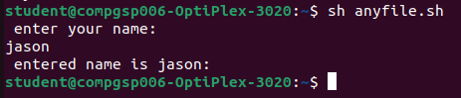

printf -&gt; print stmt in same line

echo - prints stmt in next line

$a = %d (in c)

to assign a vlaue in a variable do

c = $a

#logical operators

#-a for and (&amp;&amp;)

#-o for or (||)

#-nt for not

#-eq for equal

#-ne for not equal

#-gt greather than

#-ge for greater than equal to

#-lt for lesss than

#-le for less than equal to

#if condition

if [command(condition)] //if [ $a -gt $b ] i.e a &gt;b

then

command

fi

#if else condition

if [command(condition)] //if [ $a -gt $b ] i.e a &gt;b

then

command

elif [condition]

then

command

else

command

fi

#file comparision

-f file exists and it is regular file

-r it is readable

-w it is writable

-x it is excutable

-s check if file size is greater than 0

-d dir or not

String comparison

== equal strings

!= not equal strings

Switch case

Syntax

Case expression in

pattern1) command;; //

pattern2) command;;

*) echo “invalid”

esac

#String handling

1) Determining the length of the string

syntax

`expr &quot;OS&quot; : &#39;.*&#39;`

expr - it can be used for arithmetic operation and integers and manupulating strings

2]

// program

echo " enter three number:"

read a b c

if [ $a -gt $b -a $c ]

then

echo " A: $a is greater "

elif [ $b -gt $c ]

then

echo " B: $b is greater "

else

echo "c: $c is greater "

fi

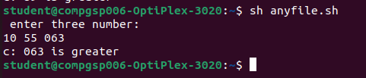

3]

echo " select the state "

echo "A.Goa B.Gujarat C.Haryana"

read value

case $value in

A|a) echo "Panaji";;

B|b) echo "Gandhinagar";;

C|c) echo " Chandigarh";;

*) echo "Invalid"

Esac

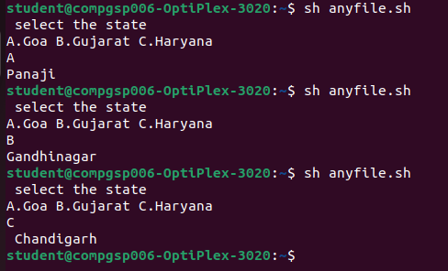

4]

//

echo " enter two number:"

read a b

c=`expr $a + $b`

echo " addition of $a and $b = $c" //

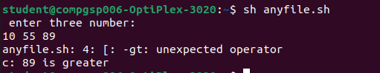

5]

// #determing length of the strings

c=`expr "Operating System " : '.*'`

echo $c //



6]

// #accept a sub string

strg=2003

c=`expr "$strg" : '..\(..\)'`

echo $c //

7]

// #locating position of the character in a string

#lets find out first occurence of &quot;operating systems&quot;

c=`expr "Operating System" : '[^e]*e'`

echo $c //

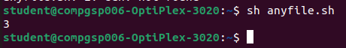

8]

// ;while loop

Syntax

while [condition is true]

do

command

done //

num=5

while [ $num -le 10 ]

do

echo $num

num=`expr $num + 1`

done

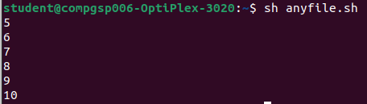

9]

// ; for loop

syntax

for variable in list

do

command

done

example

for i in 1 2 3 4

do //

i=`expr $i + 1`

echo $i

done //

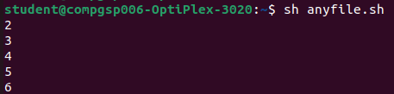

10]

//

for (( i=1; i<=10;i++))

do

i=`expr $i + 1`

echo $i

done //

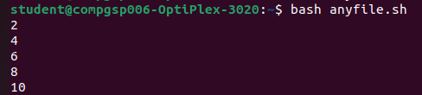

*OS Lab, Department of Computer Engineering* RollNo.22CO61